Activity Diagram
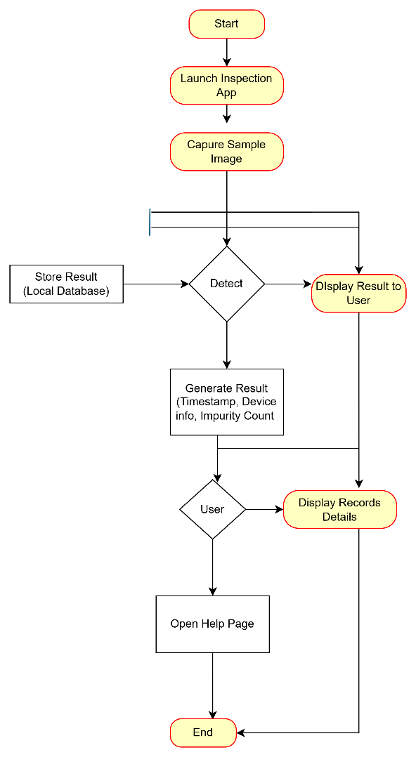

Use Case
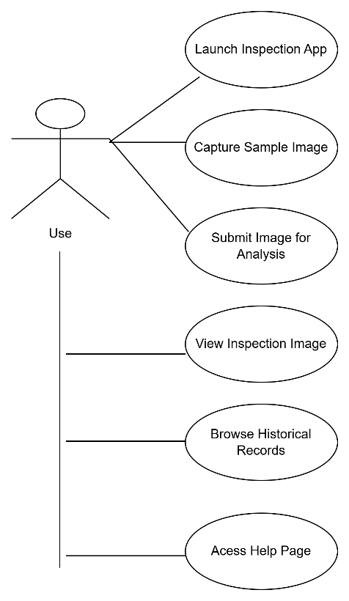

Class Diagram
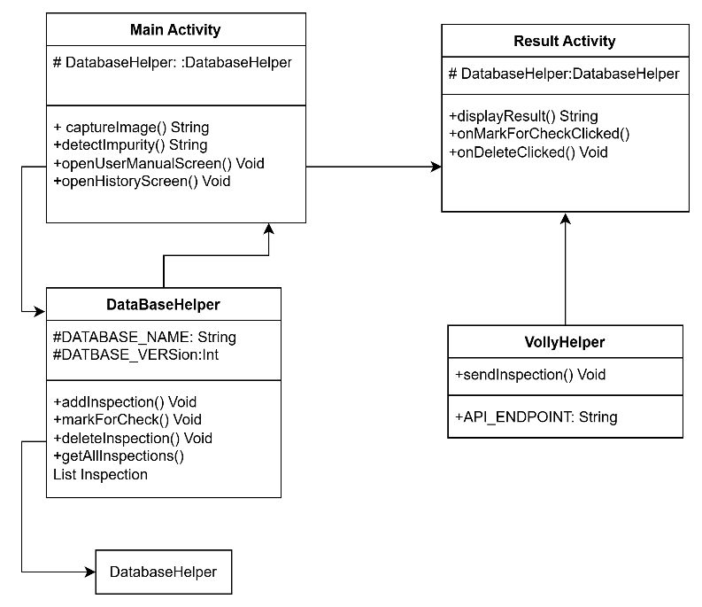

Sequence Diagram

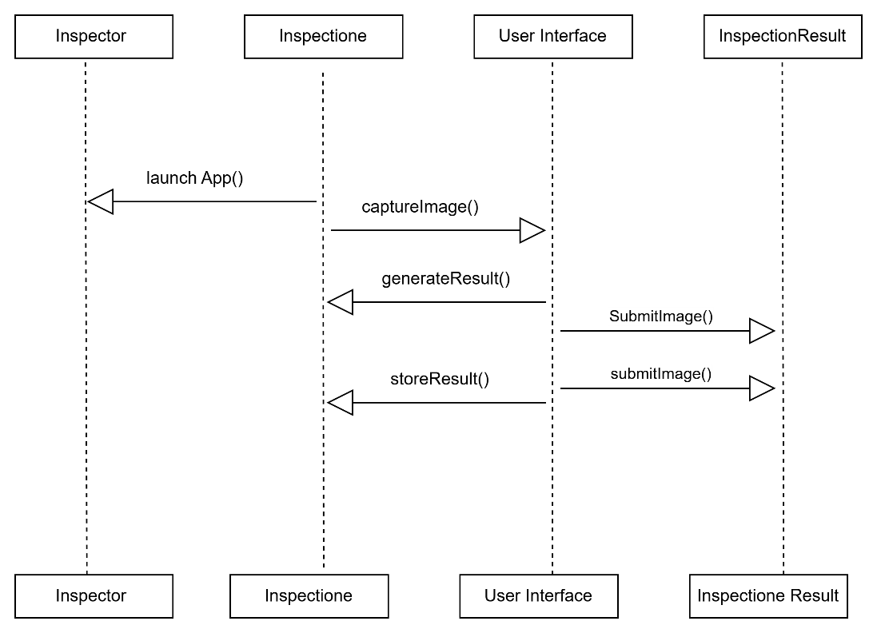

State Machine Diagram
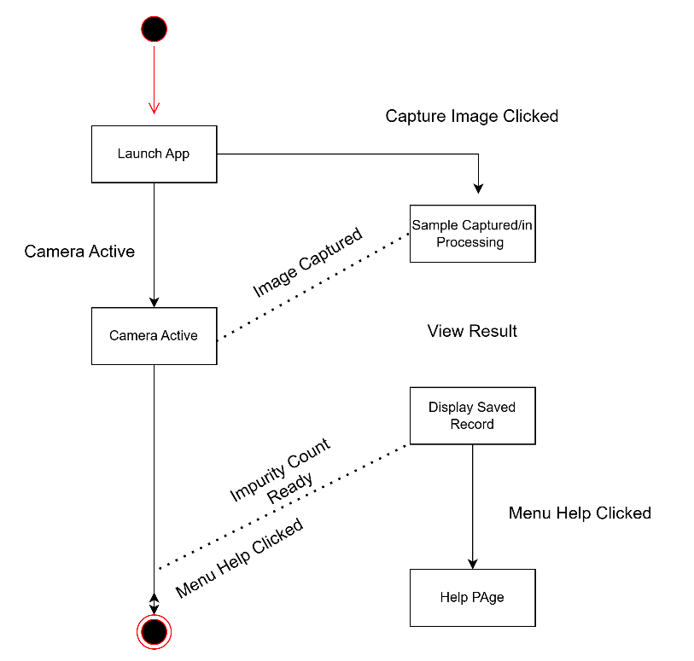

Background
Factory A produces Polyvinylidene Chloride (PVDC), a resin used in coatings and food packaging for its barrier properties. Mechanical wear and manual handling during production introduce coloured impurities, affecting quality. To address this, 3% of each 100-ton batch is manually inspected straining staff and risking visual fatigue. To improve accuracy and scalability, Factory A proposed an Android app using computer vision to automate inspection. Inspectors capture sample images via mobile camera; the app detects impurities and classifies quality. Data is stored locally and synced to a cloud database with compression. This reduces manual workload, enhances consistency, and supports long-term quality assurance. The factory has defined development requirements to ensure the app meets industrial standards and integrates with existing workflows
Feasibility Analysis and Development Plan
Before development, it’s vital to assess the feasibility of a computer vision-based Android app for PVDC inspection. Technically, Android supports camera access and tools like OpenCV or TensorFlow Lite to detect coloured impurities via texture and colour analysis. Operationally, the app fits Factory A’s workflow, replacing manual inspection of 3% of each batch. This reduces fatigue and improves consistency. Economically, while development requires resources, it offers long-term savings by lowering labour costs and improving quality. Risks like poor image capture or data loss can be mitigated through clear guidelines, diverse training samples, and secure cloud storage. Development begins with requirement gathering, followed by prototyping, model training, and factory testing. Future updates may include analytics and system integration.
Subsection 2.1 One
This project is developed as a native Android app using Java to ensure full access to device hardware and system APIs like the camera, storage, and sensors crucial for real-time image capture and processing of PVDC samples. Java, an official Android language, enables use of core libraries and broad device compatibility. Development is done in Android Studio, Google’s official IDE, which supports Java, UI design, resource management, testing, and performance profiling. It also provides access to the latest SDKs for implementing camera access, SQLite storage, and cloud integration. Native development ensures smooth performance, responsive input handling, and reliable integration with Android features—essential for a technical app where speed, stability, and compatibility directly impact success.

2.2 Subsection Two
A key feature of the proposed Android app is automatic camera activation via a UI button, enabling instant image capture of PVDC resin samples without manual setup. Once captured, the image is saved locally and sent to the detection interface for analysis. This interface displays the sample, a progress indicator, and real time impurity detection using computer vision. Results appear in a structured format, including timestamp, device info, and impurity quantification. All records image, metadata, and results are securely stored for future review and quality tracking. This end-to-end workflow ensures fast, automated inspections with reduced manual effort and improved consistency. It supports Factory A’s goal of enhancing resin quality control through reliable, scalable digital tools.
Requirements Analysis
The system will be a native Android app built in Java using Android Studio for optimal performance and compatibility. It will access camera APIs, storage, and background services for real time PVDC sample inspection. In Inspection Mode, users capture images via a button triggered camera images are saved locally and analysed for impurities. Results include timestamp, device info, and impurity data. Re-inspection Mode lets users select stored images for re-analysis. Historical Records displays all past inspections with detailed metadata. A User Manual provides step by step guidance, troubleshooting, and feature descriptions. These features ensure fast, automated, and well documented inspections. Together, they form a robust, user friendly system that improves consistency, reduces manual effort, and supports PVDC resin quality control.

Design
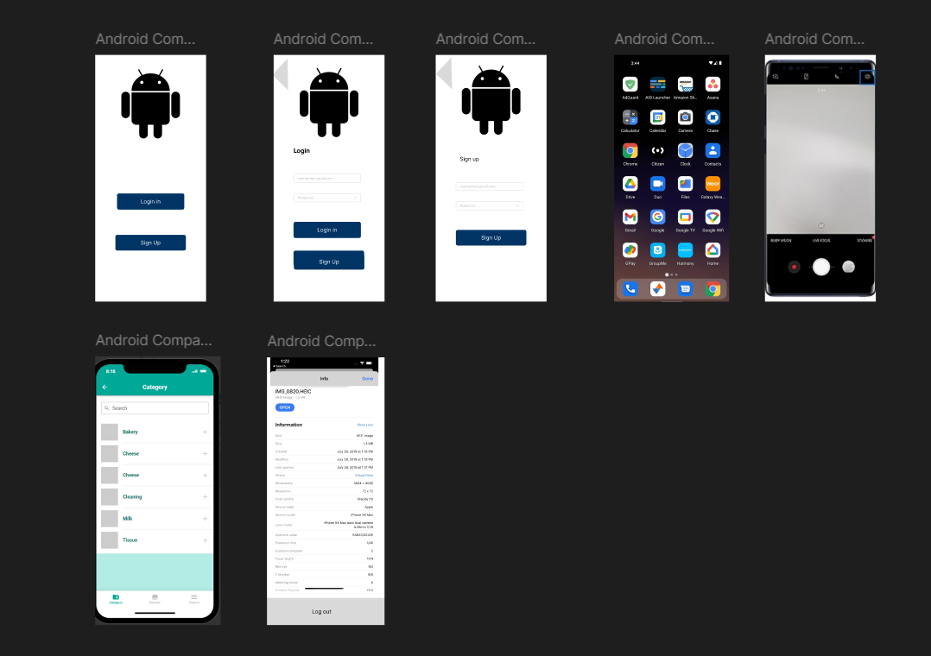

This prototype showcases an Android app for user authentication, expense tracking, and camera-based utilities. Key features include:
• Login & Sign Up: Secure access and account creation
• Home Interface: Standard Android icons for easy navigation
• Camera Module: Capture photos/videos for receipts or documentation
• database: show what fields are stored there.
The design prioritizes simplicity and modularity, ideal for users seeking a lightweight tool to manage daily expenses and capture visual data.
Database design
Field Name | Data Type | Example Value | Description
Id | Integer | 1 | Unique identifier (Primary Key, auto-incremented
Image Path | Text | /image/img_001.jpg | File path to the inspection image
Timestamp | Text | 2025-11-18 10:15:00 | Time the inspection was recorded
Status | Text | Passed/Failed | Status of the inspection (e.g., passed/failed)
Device Info | Text | Pixel 6-Andriod14 | Info about the device used for inspection

This table was created using SQLite in Android Studio. It supports the inspection app’s data storage and aligns with the Class Diagram structure.
Java format for class diagram
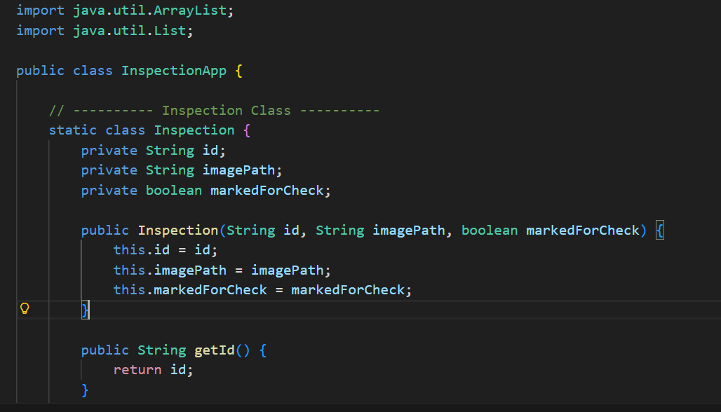
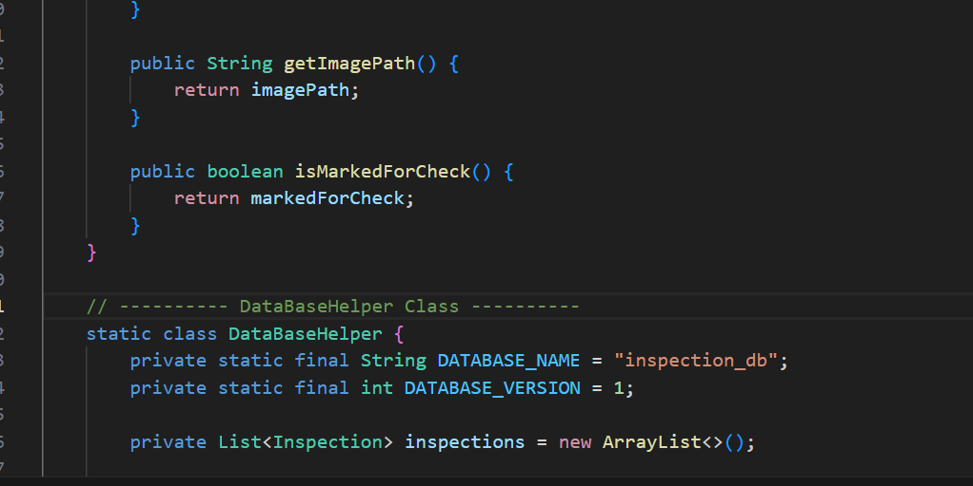
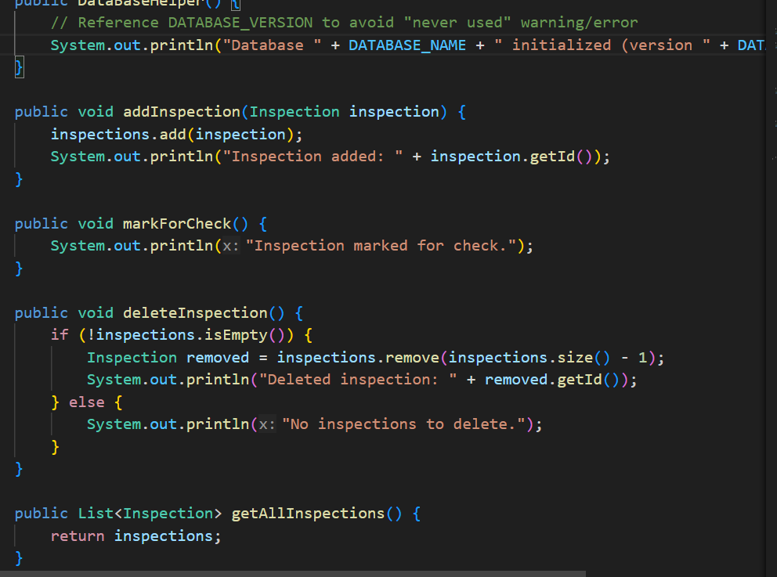
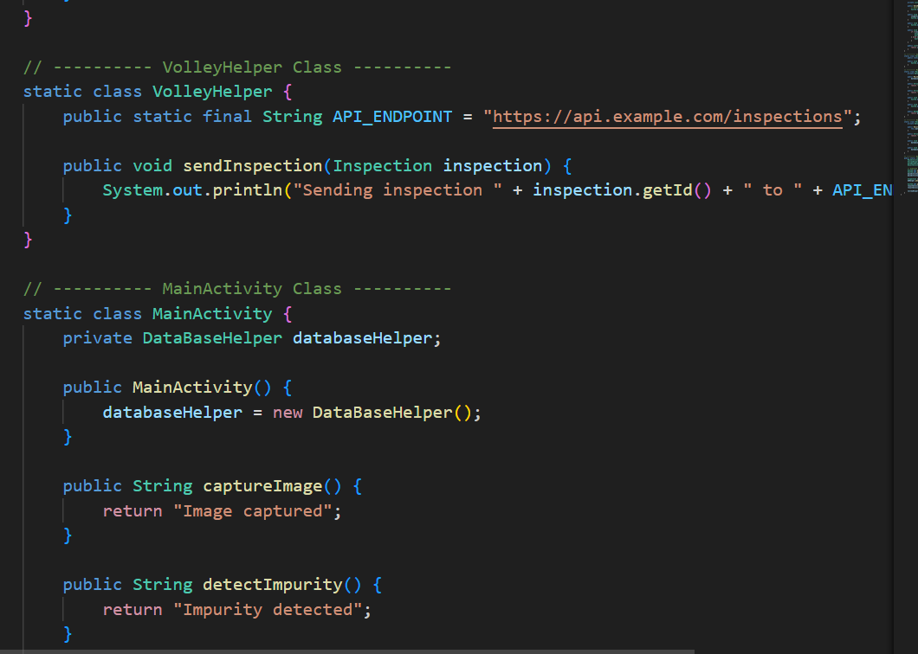
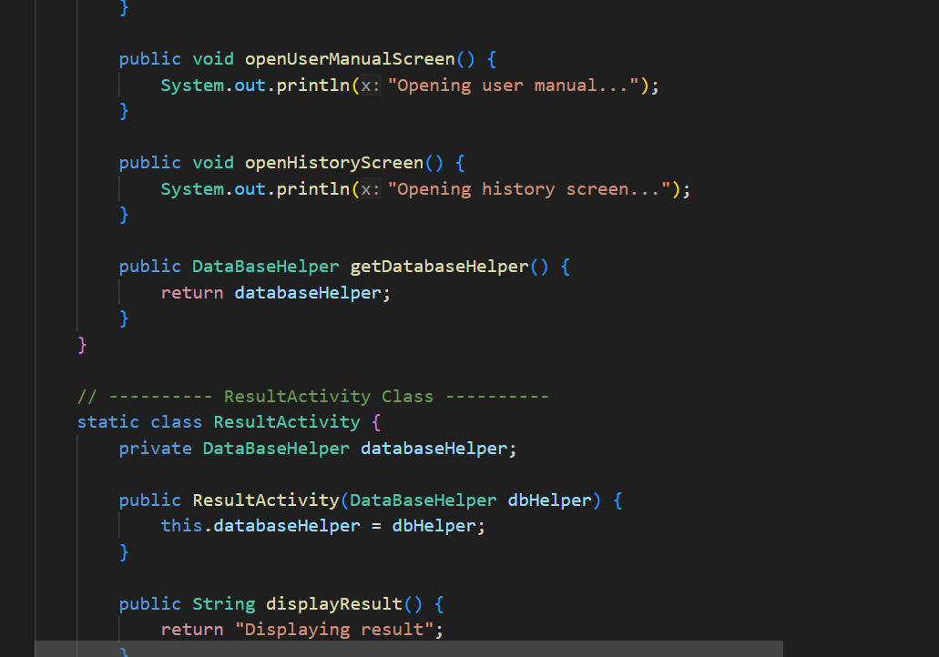
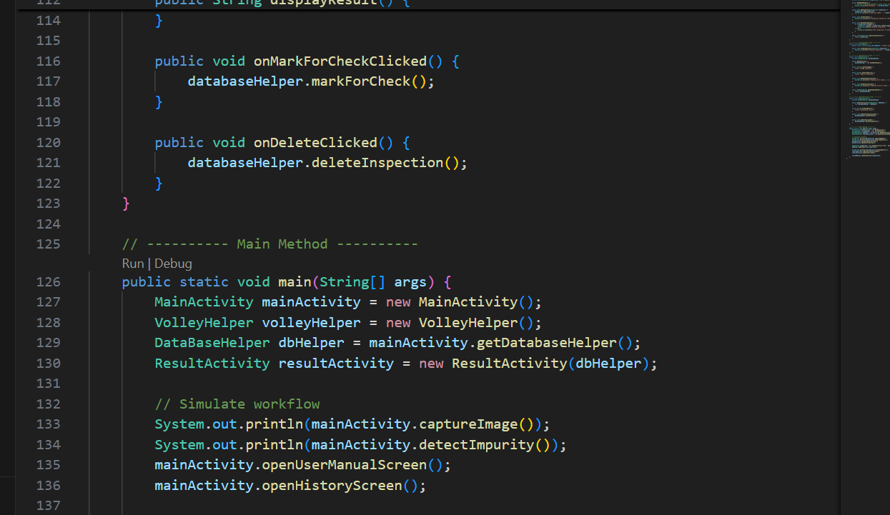
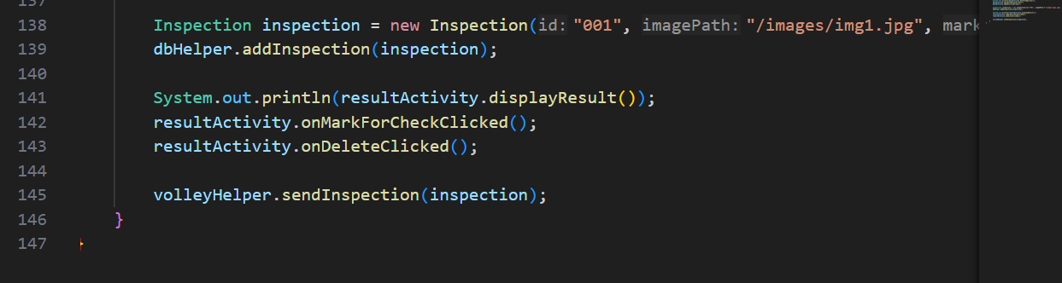

References
Microsoft Copilot. (2025, November 18). Microsoft Copilot. https://copilot.microsoft.com
This Assignment Used Generative AI in the following ways: Brainstorming, Planning Feedback and Editing

